Practical 2: Simulation of different network topologies and comparative study of each. (using CISCO packet tracer)

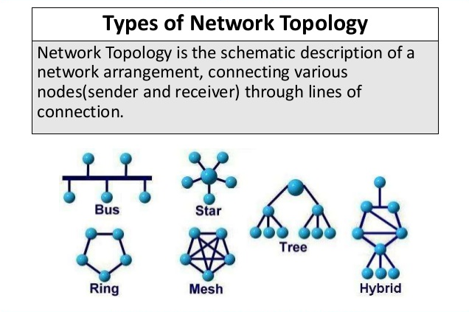

1. **Mesh topology**

* In mesh topology every machine is connected to each and every other machine in the system.
* Because of that many connections to each pc:
* Advantages:

1. Whenever any connection between any of two PCs is disconnected, we can still send signals via other PC’s connection wiring.
2. Due to direction connection of every machine, the data transmission speed is really fast, so this topology operates at higher speed than other topologies.

* Disadvantages:

1. The wiring of this particular system become very complicated & time consuming.
2. Also, if there are n machines in the system, each machine need (n-1) port for connecting every other pc to it, which is not possible so we have to connect some intermediate device which increase complexity as well as cost & maintenance.
3. Addition of new machine is very complicated & time consuming.
4. **Star topology**

* In star topology, there is one intermediate device to which all the PCs are connected. It can be switch or hub or devices like them.
* Advantages:

1. In star topology, the wiring is very less compared to mesh topology. So the network is really simple.
2. When switch is used as intermediate device, the transmission is faster than with hub as switch is 2-layer device.
3. The port required in each PC is only 1.

* Disadvantages:

1. If this intermediate device fails, the whole system will fail & stop communicating.
2. When a data transmission is ongoing, the other PCs have to wait to send their data to other PC.

* This topology is used in institutes/organizations with more number of PCs to connect them all & create a local area network ( LAN).

**The difference between SWITCH and HUB:**

|  |  |
| --- | --- |
| **SWITCH** | **HUB** |
| IT IS SMART DEVICE, IT CAN UNDERSTAND THE MAC ADDRESS OF SOURCE & DESTINATION MACHINE. | **HUB IS A DUMB DEVICE,IT DIDN’T UNDERSTAND THE ADDRESSES OF MACHINES.** |
| Because of this reason it sends data only to the desired machine rather than transmitting it over the network. | As HUB don’t understand the address of destination address, it just transmits the data through network without sending it to the port from where the message came. |
| **It is 2-layer device so it can read the MAC address of the machine from the message received.**  **The MAC address of the machine is stored inside it at source side.** |  |
| The message has 3 parts:  1)source-PC’s MAC address  2)destination-PC’s MAC address  3)data/signal |  |

• So how SWITCH send data particularly to a PC?

• Answer is it creates a table of port & MAC address of the pc connected at that port. So if one is sending data first time in system the table is not created yet so it’ll work as hub only but after each signal it memorize the source address & stores it in table in opposite of that particular port.

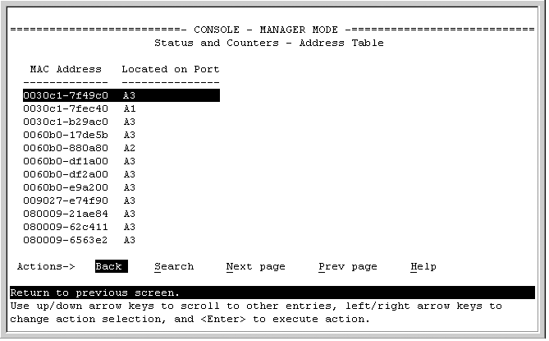

* Table of MAC address & port of PCs in SWITCH

1. **Ring topology**

* In ring topology, every PC is connected to two nearby PCs & it creates a circle/ring in that manner.
* Advantages:

1. The connection port required are only 2, which is less than mesh topology.
2. If the connection between any 2 PC is broken, we can still send data via other path of ring.
3. Addition of a new PC is very easy, just have to connect it to nearby 2 PCs.

* Disadvantages:

1. If the connection broken is 2 or more, then the system will fail to communicate.
2. The speed of data transmission is very slow, as it has to move to every PC which are not intended to receive a particular message.

* Ring topology is used for Long-haul or medium-haul WAN networks between multiple locations.

1. **Bus topology**

* A bus topology is a topology for a Local Area Network (LAN) in which all the nodes are connected to a single cable. The cable to which the nodes connect is called a "backbone". If the backbone is broken, the entire segment fails.
* Advantages:

1. The main advantage of this system is the need of less wiring. Also when we have to add other machine it is very simple.

* Disadvantages:

1. As stated above, if main “backbone” cable fails than whole system fails.
2. Again the speed of data transmission is slow.

* This type of topology was used earlier for Ethernet & also used in cable TV connection in our life.